COMPANY PROFILE · 2026



Sunlight into
Farmer Income.
A Kenyan climate-smart agribusiness turning solar energy into resilient rural livelihoods.

Nairobi, Kenya · sundaraafrica@gmail.com · +254 701 028 284 · sundara.africa

AT A GLANCE
Sundara Africa is a Kenyan climate-smart agribusiness turning sunlight into farmer income. We design and deploy IoT-enabled solar drying systems and productive-use solar solutions that reduce post-harvest losses, extend shelf life, and unlock premium markets for African smallholders.

40%  harvest lost post-picking | 400+  kWp solar deployed | 30+  institutions solarized | 2  German R&D partners

Who We Are
Sundara Africa operates at the intersection of renewable energy and agriculture. Our mission is to reduce post-harvest losses and improve farmer incomes through solar-powered agricultural processing technologies — beginning with solar drying.
We believe renewable energy should do more than provide electricity. It should create livelihoods, improve food security, and stimulate rural economic growth. Our vision is to become a leading provider of solar-powered agricultural value-addition solutions across Africa.

“Renewable energy should do more than light homes — it should build livelihoods.”

THE CHALLENGE WE ADDRESS

High Post-Harvest Losses
A significant portion of African agricultural produce is lost after harvest due to inadequate drying, storage, and processing infrastructure — leading to reduced incomes, market inefficiencies, and increased food insecurity.

Limited Productive-Use Energy
Many rural farmers and households lack reliable, affordable energy that translates into income. This limits productivity, restricts irrigation, and undermines the ability to preserve and add value to produce.

The consequence: farmers sell raw produce at low prices during peak seasons, losing the significant potential income that value addition would deliver.

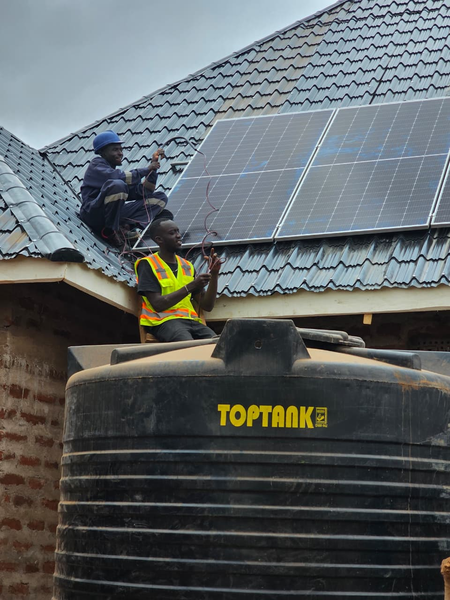
Sundara field installation — rural Kenya

OUR SOLUTIONS
A three-engine model designed to deliver impact while sustaining commercial growth.

Solar Drying
Impact Engine
- Reduces post-harvest losses and extends shelf life
- Improves product quality and market grading
- Enables access to premium markets and off-take agreements
- Multiplies farmer income through value addition

Solar for Farmers
Revenue Engine
- Solar water pumping systems
- Irrigation and productive-use energy
- Farm backup power solutions

Residential Solar
Cash Flow Engine
- Solar home systems and backup power
- Energy-efficiency installations
- Fast revenue cycles to fund operations and expansion

SOLAR DRYER PROTOTYPES
Three field-tested designs sized to different farmer segments — from smallholders to cooperatives and agro-processing hubs.

15 KG  Cabinet Dryer  For smallholders and household agro-processors. | 50 KG  Cabinet Dryer  For farmer groups and small cooperatives. | 300 KG  Greenhouse Dryer  For cooperatives and commercial hubs.

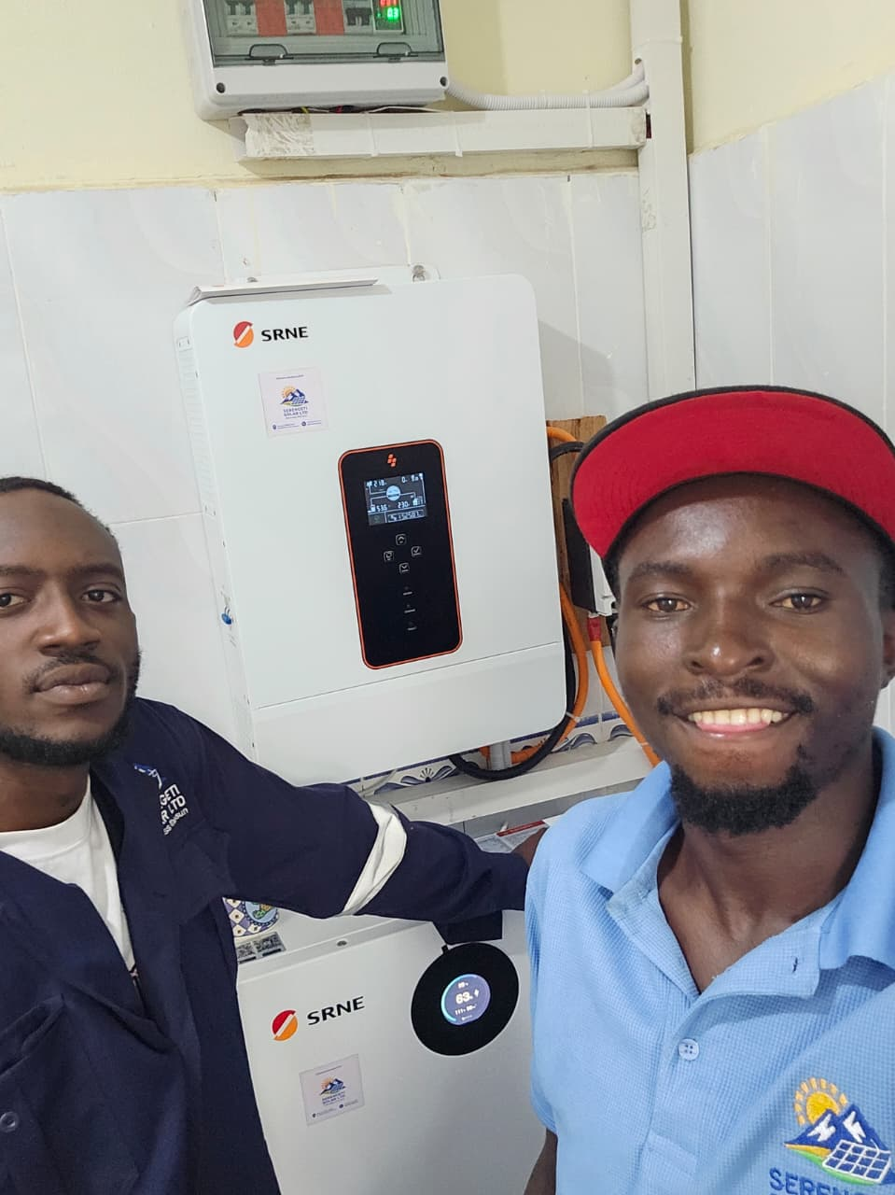
Commissioned inverter and battery bank — completed installation

BUSINESS MODEL
Sundara operates a dual-purpose business model: a high-impact agricultural value-addition platform, powered by a self-sustaining installation revenue engine.

- Impact engine: solar drying systems that transform agricultural value chains and reduce food waste.
- Revenue engine: solar installations for farmers and homes that produce immediate income and stabilise operations.

Residential and farmer installations provide stable cash flow, enabling Sundara to invest in scaling solar drying infrastructure, developing partnerships, and expanding market reach.

Market Opportunity
- Agriculture: high post-harvest losses represent a major economic gap across African food systems.
- Renewable energy: rising demand for off-grid and decentralised solar across rural and peri-urban Africa.

TRACTION
- Completed solar installations for farmers and households across Kenya.
- Ongoing engagement with agricultural communities and farmer networks.
- Active development and field testing of Sundara-designed solar dryers (15 kg, 50 kg, 300 kg).
- Established R&D partnerships with the University of Hohenheim and INNOTECH Technologies (Germany).
- Founders bring 400+ kWp of installed solar capacity across 30+ solarized institutions.

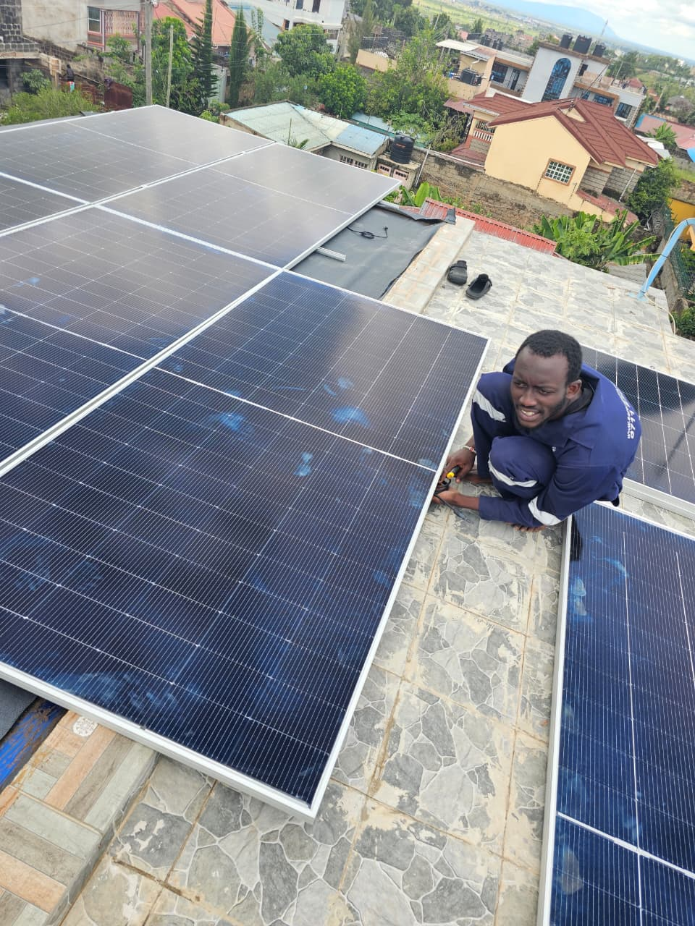
Rooftop solar installation, Nairobi metro

LEADERSHIP

Benaiah Namunyu
Co-Founder & CEO · Business Development
Technical Sales Lead at Sentinel Energy, one of Kenya's growing renewable energy companies. Deep field experience across Kenya's solar and off-grid energy markets, with a track record of building relationships with farmers, cooperatives, and institutional buyers.

Faizal Toloi
Co-Founder · Technical Lead
Technical development lead. Specialist in solar system design and installation, overseeing Sundara's solar drying projects and productive-use installations from engineering through commissioning.

Our Team in the Field
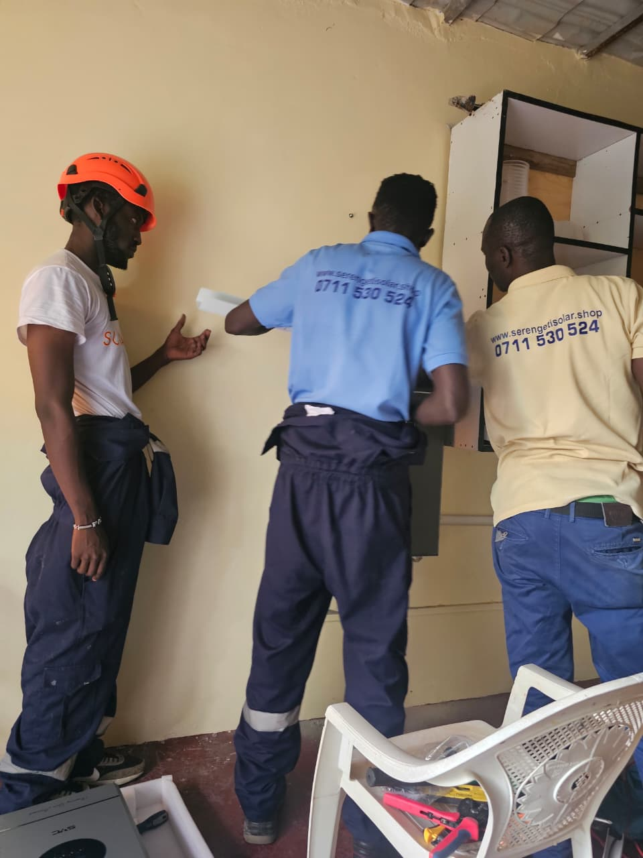 | 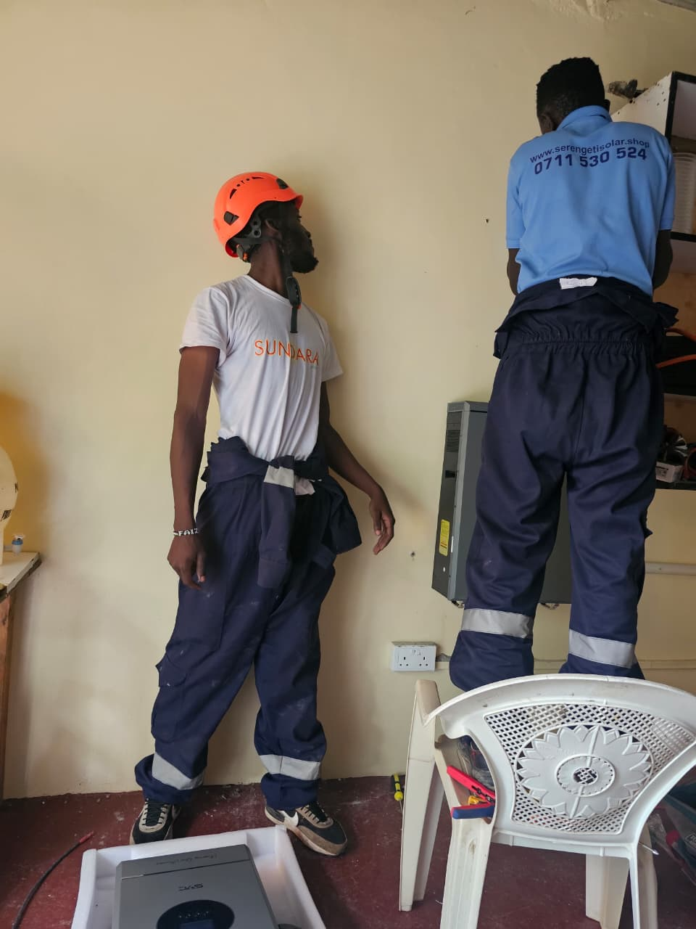

COMPETITIVE ADVANTAGE
- Integrated agriculture + renewable energy expertise under one roof.
- Income-generating focus — not energy access alone.
- Dual-engine model that generates cash while building long-term impact infrastructure.
- Strong grassroots engagement with farmers and rural institutions.
- Scalable across multiple agricultural value chains and geographies.

GROWTH STRATEGY
- Scale solar drying through farmer groups, cooperatives, and school-based hubs.
- Expand solar irrigation and productive-use energy across rural regions.
- Strengthen partnerships with agricultural aggregators and market actors.
- Develop structured off-take and market linkages for dried products.
- Grow residential and farmer solar installations as a revenue stabiliser.
- Expand across key agricultural regions in Kenya and East Africa.

INVESTMENT OPPORTUNITY
Sundara Africa presents an opportunity to invest in a scalable climate-smart agribusiness tackling two critical challenges — food loss and rural energy access — with a built-in commercial revenue engine that reduces investment risk while enabling long-term scalability and measurable impact.

Use of Funds
- Scale solar drying infrastructure and pilot hubs.
- Expand field operations and installation capacity.
- Strengthen market linkages for agricultural products.
- Support working capital and growth execution.

LET'S BUILD TOGETHER
Contact
Benaiah Namunyu
Co-Founder & CEO, Sundara Africa
Nairobi, Kenya
sundaraafrica@gmail.com · benaiahnamunnyu@gmail.com
+254 701 028 284
sundara.africa

