
CONCEPT NOTE
Technology Transfer Mission for Scaling Solar Drying
Transforming Energy Access into Agricultural Prosperity
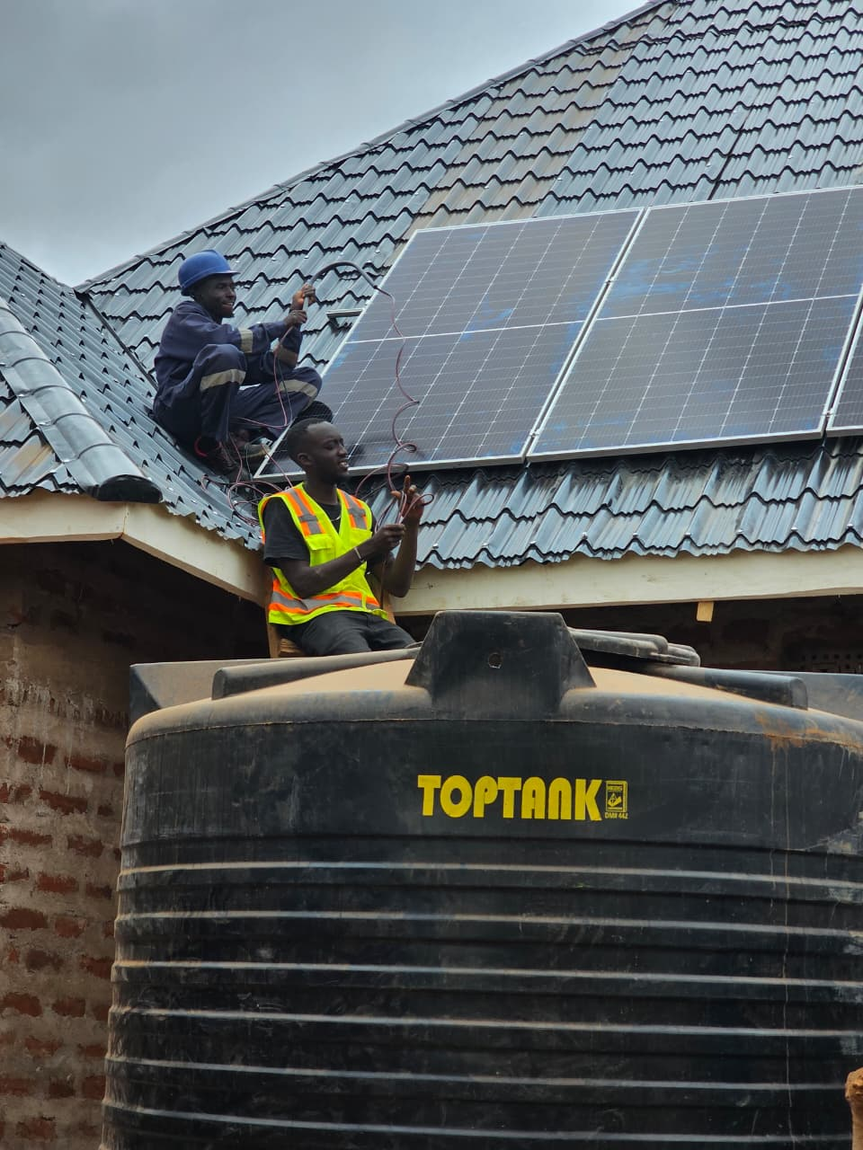

Prepared by Sundara Africa · Nairobi, Kenya
sundaraafrica@gmail.com · +254 701 028 284 · www.sundara.africa

01 · Introduction

Across Africa, millions of smallholder farmers continue to lose a significant portion of their harvest due to inadequate preservation and processing technologies. While renewable energy access has expanded considerably over the last decade, productive-use applications capable of generating income and strengthening food systems remain underdeveloped.
Sundara Africa was established to address this challenge.
Our mission is to reduce post-harvest losses and improve farmer incomes through solar-powered agricultural processing technologies, beginning with solar drying solutions.

Our Belief
Renewable energy should do more than provide electricity — it should create livelihoods, improve food security, and stimulate rural economic growth.

02 · About Sundara Africa

Sundara Africa is a Kenyan climate-smart agribusiness focused on renewable-energy-powered agricultural value addition. The company develops and promotes solar drying solutions that help farmers preserve produce, access higher-value markets, and reduce losses caused by spoilage.

Our Vision
To establish decentralized Solar Drying Hubs across Africa that serve farmers, schools, cooperatives, and rural enterprises — processing fruits, vegetables, herbs, and grains using clean and affordable solar energy.

Founding Team

Sundara Africa was founded by Benaiah Namunyu (Business Development) and Faizal Toloi (Technical Development) — both renewable energy professionals, entrepreneurs, and youth leaders with practical field experience in Kenya.

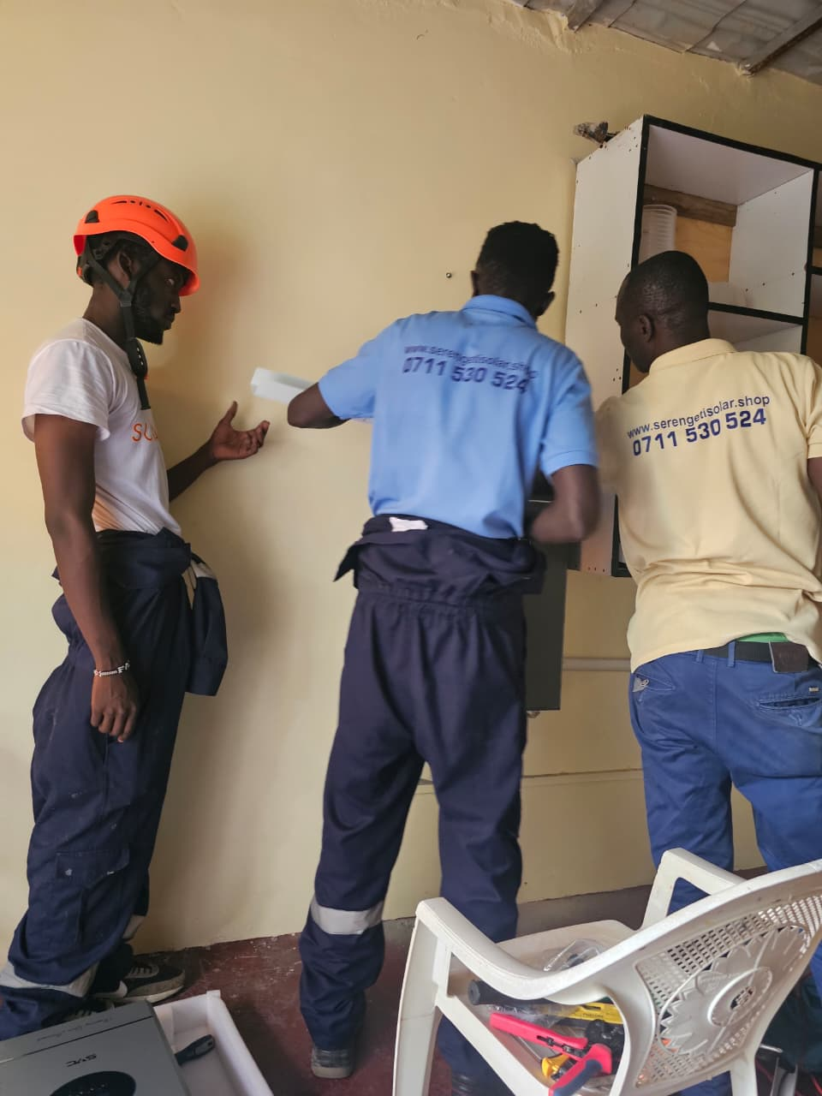  Benaiah Namunyu — Co-Founder & CEO | 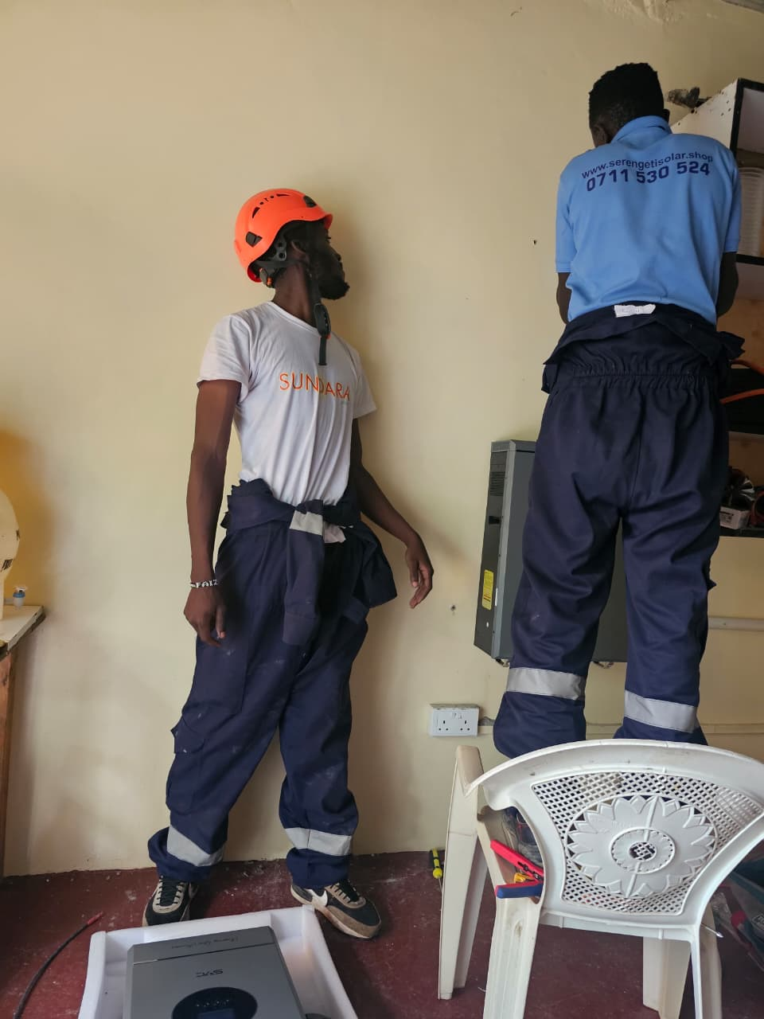  Faizal Toloi — Co-Founder & Technical Lead

Benaiah serves as Technical Sales Lead at Sentimental Energy and has supported the solarization of more than 30 learning institutions across Kenya, representing over 400 kWp of installed solar capacity.
Faizal leads solar technology installations and system design, and manages the technical execution of Sundara projects.

03 · Why Solar Drying

Agricultural losses remain one of the biggest barriers to farmer prosperity in Africa. Up to 40% of harvest is lost because products cannot reach markets quickly enough or because preservation options are limited.

The 40% problem
Solar drying offers a practical, clean-energy solution to preserve produce, extend shelf life, and unlock premium markets for smallholder farmers.

Benefits of Solar Drying:
- Extends shelf life of perishable produce
- Improves product quality and consistency
- Creates value-added products for premium markets
- Increases farmer incomes through processing
- Improves household and community food security
- Reduces dependence on fossil-fuel-based drying methods

However, challenges related to efficiency, technology design, scalability, and technical expertise continue to limit widespread adoption.

04 · Technology & Partnerships

Sundara Africa designs and deploys IoT-based solar-powered drying systems that enable farmers to preserve fruits, vegetables, grains, herbs, and other agricultural products in a clean, efficient, and cost-effective manner.

Our solution:
- Reduces post-harvest losses and extends product shelf life
- Improves product quality and market-readiness
- Enables access to premium regional and export markets
- Increases farmer income through on-farm value addition

Strategic R&D Partners

University of Hohenheim — Germany
A globally recognized institution with extensive expertise in agricultural engineering, post-harvest technologies, and solar drying systems. Together we are designing and testing energy-efficient solar dryers optimized for African market fit.

INNOTECH Technologies — Germany
An innovative company with expertise in advanced drying technologies and industrial solutions deployed across more than 110 countries.

Solar Dryer Prototypes

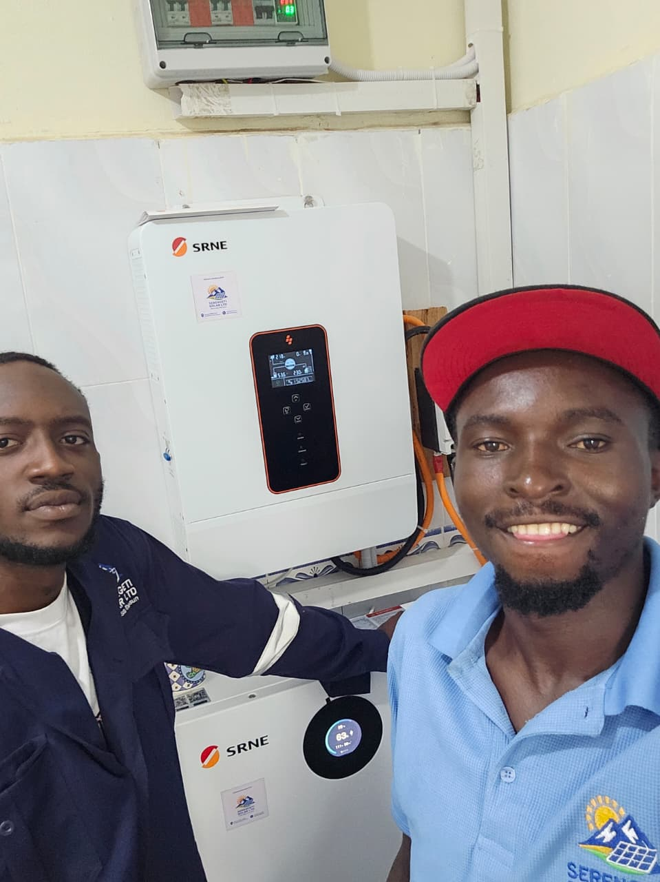  Cabinet Solar Dryers | 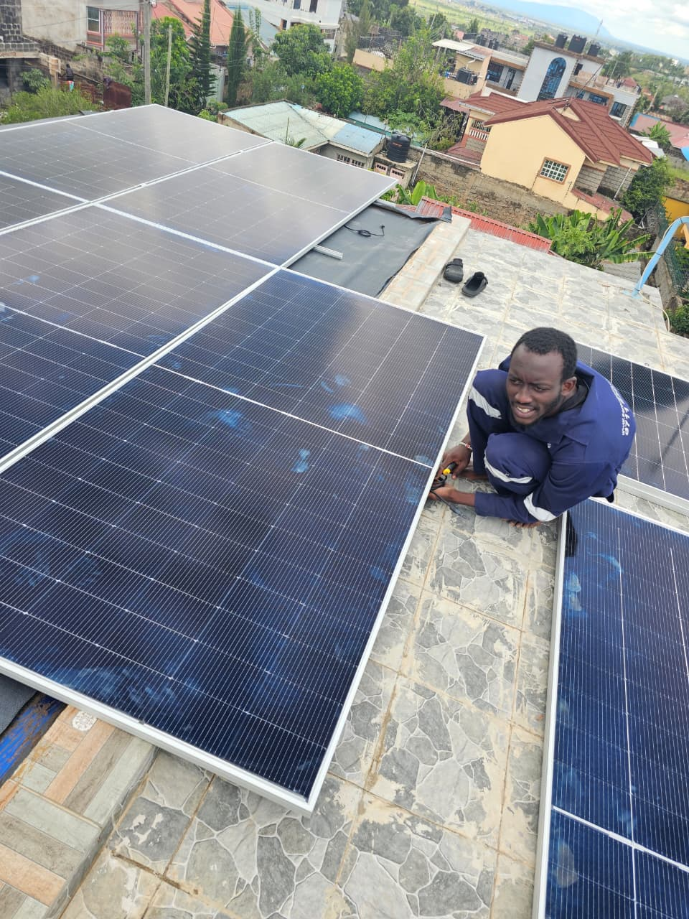  Greenhouse Solar Dryers

Sundara is currently piloting three prototypes: a 15 kg cabinet dryer, a 50 kg cabinet dryer, and a 300 kg greenhouse dryer — each tuned for a different farmer segment.

05 · Proposed Technical Exchange

The proposed two-week mission will enable Sundara Africa to strengthen its technical foundation and accelerate deployment across East Africa.

Mission objectives:
- Exchange and refine global best practices in solar drying design and operation
- Develop and test innovative drying technologies adapted to African conditions
- Explore research and development collaborations
- Develop a roadmap for technology localization and deployment
- Strengthen partnerships for future pilot projects
- Support local manufacturing opportunities in East Africa

Vision: School-Based Solar Drying Hubs

Building on existing renewable energy infrastructure, Sundara Africa is developing a model that transforms solarized schools into productive-use energy hubs — in partnership with local solar providers.

One model. Five multipliers.
These School-Based Solar Drying Hubs leverage existing solar installations, available land, community trust, youth engagement, and established institutional structures.

The hubs will serve surrounding farming communities while creating new educational and entrepreneurial opportunities for students — linking energy access, agriculture, education, and rural development within a single scalable model.

06 · Expected Impact

Through this technology transfer mission and the deployment of Solar Drying Hubs, Sundara Africa expects to:
- Reduce post-harvest losses by up to 40% among partner farmer groups
- Increase farmer income through value-added agro-processing
- Create rural employment and youth entrepreneurship opportunities
- Strengthen food security in target communities
- Advance climate-smart, low-carbon agriculture across East Africa

Support Requested

Sundara Africa is seeking strategic partners interested in supporting this 2-week technology transfer mission through:
- Travel sponsorship for the founding team
- Pilot project funding and equipment support
- Research & development collaboration

The mission will facilitate the transfer of knowledge and expertise required to scale climate-smart agricultural solutions that improve livelihoods across Africa.

LET'S BUILD THIS TOGETHER
Benaiah Namunyu
Co-Founder & CEO, Sundara Africa
Technical Sales Lead, Sentimental Energy
📞 +254 701 028 284
✉ sundaraafrica@gmail.com
🌐 www.sundara.africa
📍 Nairobi, Kenya

