
SOLAR SYSTEMS BROCHURE 2026
Cut your power bill.
Own your energy.
Quality solar for homes, businesses and industry across Kenya — designed, installed and serviced by Sundara Africa.
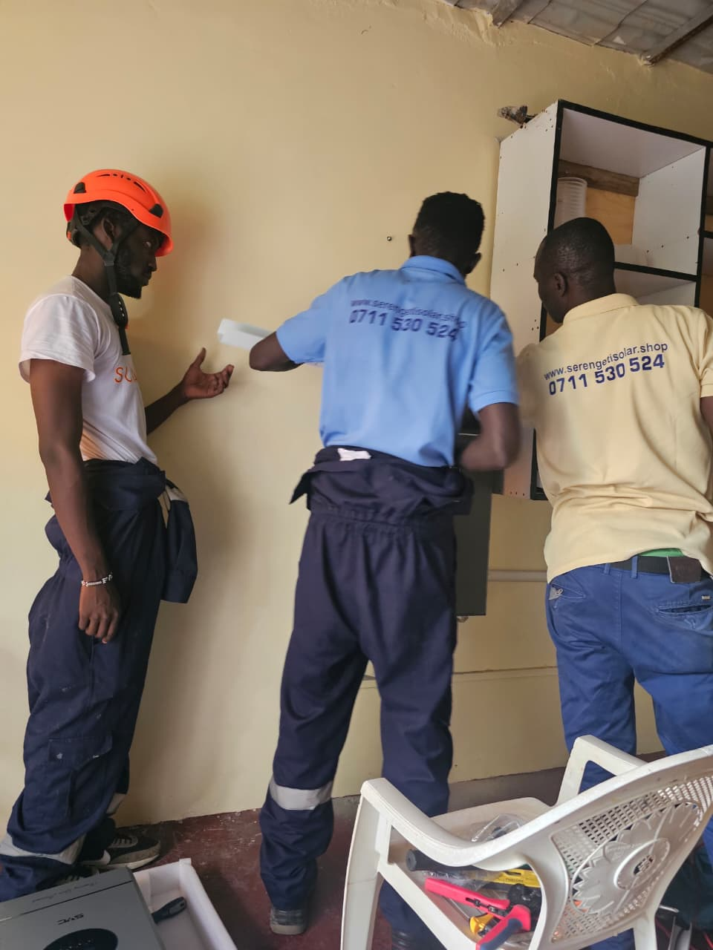
400+ kWp deployed · 30+ institutions served · Nairobi, Kenya

WHY SOLAR, WHY NOW
Electricity is a cost. Solar is an asset.
Kenyan households and businesses face rising KPLC tariffs, unreliable supply and expensive diesel backup. A quality solar system turns a monthly bill into a one-time investment that pays back in a few years and keeps producing for decades.

40–70%  Reduction in electricity spend | 3–5 yrs  Typical system payback | 25 yrs  Panel performance warranty | 0 KES  Cost of a Sundara site visit

FOR HOMES
Residential Solar
Cut your KPLC bill, keep the lights on during blackouts, and turn your roof into a 25-year asset. We design, install and maintain quality solar for Kenyan homes.
What you get
- Save KES 8,000 – 25,000 per month on electricity
- Silent backup power — no more generator fuel and noise
- Payback in 3 – 5 years, 25-year panel warranty
- Boost property value with a clean-energy upgrade
Packages & typical sizing
1.5 – 3 KW · FROM KES 250K  Home Essentials  1–2 bedroom · lights, TV, fridge, Wi-Fi  - Tier-1 solar panels  - Hybrid inverter  - Lithium battery backup  - Full installation & commissioning | 4 – 6 KW · FROM KES 550K  Family Home  3–4 bedroom · whole-house daytime + backup  - High-efficiency panels  - Hybrid grid-tie inverter  - Expanded lithium storage  - Monitoring + 2-yr workmanship warranty | 8 – 15 KW · FROM KES 1.2M  Independence  Large home, borehole, off-grid or hybrid  - Full off-grid / hybrid design  - Borehole & pump integration  - Large lithium bank  - Remote monitoring + priority support

FOR BUSINESSES & INSTITUTIONS
Commercial Solar
Slash operating costs for offices, schools, hospitals, hotels, retail and SMEs. Grid-tie and hybrid solar that pay back in 3 – 5 years and lock in energy costs for 25.
What you get
- Reduce electricity spend by 40 – 70%
- Protect operations from outages and load-shedding
- Strengthen ESG and sustainability reporting
- Financing and lease-to-own options available
Packages & typical sizing
10 – 30 KWP  SME & Retail  Shops, clinics, restaurants, small offices  - Rooftop grid-tie solar  - Optional battery backup  - Net-metering ready  - Performance monitoring | 30 – 150 KWP  Institutional  Schools, hospitals, hotels, agri-processors  - Structural roof assessment  - Hybrid solar + battery  - Generator integration  - O&M service contract | 150 – 500 KWP  Large Commercial  Manufacturing, cold storage, campuses  - Custom engineering design  - PPA / lease financing  - SCADA-grade monitoring  - 24/7 support + annual audits

FOR INDUSTRY & AGRI-PROCESSING
Industrial & Productive-Use Solar
Bankable MW-scale solar and productive-use systems for factories, agri-processors, irrigation and cold chains. Engineered for uptime, financed for growth.
What you get
- Displace expensive grid and diesel power
- Power irrigation, cold rooms, milling, drying and processing
- Bankable design for lenders, DFIs and off-takers
- EPC delivery with international R&D partners
Packages & typical sizing
IRRIGATION · COLD · MILLING · DRYING  Productive-Use Solar  Farms, cooperatives, agri-SMEs  - Solar water pumping  - Solar cold rooms  - Solar dryer hubs (15 – 300 kg)  - Farmer-financing structures | 500 KWP – 5 MWP  C&I Rooftop / Ground  Factories, warehouses, agro-industrial parks  - Feasibility & yield study  - Grid-tie or hybrid EPC  - Battery energy storage (BESS)  - Long-term O&M contract | CUSTOM SCALE  Mini-Grid & Custom EPC  Estates, campuses, productive-use hubs  - Site survey & load study  - Design, procurement, construction  - Financing partner introductions  - Handover, training & support

HOW WE WORK
A simple, transparent process from enquiry to switch-on.
01 Free site visit We visit your site, review your last 3 KPLC bills and load profile, and understand your goals.
02 Custom design & quote Engineered system design, transparent pricing, payback analysis and financing options.
03 Professional installation Certified engineers, quality Tier-1 components, structural and electrical compliance.
04 Monitoring & support App-based monitoring, workmanship warranty and responsive after-sales service.
WHY SUNDARA AFRICA
If hospitals and schools trust us, your home or business is in safe hands.
- 400+ kWp installed across 30+ institutions in Kenya
- Tier-1 solar panels, quality hybrid inverters, lithium battery storage
- Certified engineers with documented as-built handover
- Workmanship warranty and responsive after-sales service
- R&D partnerships with University of Hohenheim and INNOTECH
- Financing and lease-to-own options for commercial and industrial clients

BOOK A FREE SITE VISIT
Tell us your location and monthly KPLC bill — we’ll do the rest.
Call: +254 706 220 834
Email: sundaraafrica@gmail.com
Web: sundara.africa
Base: Nairobi, Kenya

